Addendum to the Vaccine Landscape Report: School Vaccinations in Nevada Before and During the COVID-19 Pandemic
September 2022
Prepared by: Kendall Lyons, MPH, Epidemiologist; Anjin Singh, MPH, Sr. Epidemiologist; Donald Kue, MPH Candidate and Student Intern
Special Thanks: Cathy Looc, School and Child Care Immunization Coordinator
Nevada Department of Public and Behavioral Health (DPBH)
Nevada State Immunization Program (NSIP)
In the Vaccine Landscape Report, routine childhood immunization rates were reported for the 2018 – 2021 years; however, school vaccinations were not reported for the corresponding school years. The purpose of this addendum is to analyze school required vaccinations among students in grade levels of interest—kindergarten, 7th and 12th grade—and discuss those rates within the context of the COVID-19 pandemic.
Childhood Vaccine Schedule
Vaccines are recommended by the Advisory Committee on Immunization Practices (ACIP) and Centers for Disease Control and Prevention (CDC) to ensure that the public health is safeguarded against infectious, vaccine-preventable diseases (VPDs).^{1,2} Vaccination is recommended for:
- Diphtheria, tetanus, and acellular pertussis (DTaP)
- Inactivated poliovirus (IPV)
- Measles, mumps, and rubella (MMR)
- Hepatitis A and B (HepA and HepB, respectively)
- Pneumococcal conjugate (PCV13 or PCV15)
- Varicella (VAR or chicken pox)
- Rotavirus
- Haemophilus influenzae type b (Hib)
- Tetanus, diphtheria, and acellular pertussis (Tdap)
- Meningococcal conjugate (MenACWY)
- Human papillomavirus (HPV).^{1,2}
Vaccinations are recommended by the ACIP for children of various ages, from 0-24 months, 4-6 years, 11-12 years, and 13-17 years, with the 4-6, 11-12, and 13-17-year-old age groups coinciding with school-entry periods of kindergarten, 7th, and high school enrollment.³
Nevada School Entry Requirements
All students enrolling in kindergarten, 7th grade, 12th grade, or those who are new to a Nevada school district for any grade, must be fully vaccinated per the regulations set by the DPBH. Immunizations are required for students enrolled in Nevada public, private, or charter schools and universities according to Nevada Revised Statutes (NRS) 392.435 and 394.192 and amendments to Nevada Administrative Code (NAC) 392.105, 394.250 and 441A.755. Students must prove immunity to diphtheria, tetanus, pertussis, poliomyelitis, rubella, rubeola (measles), mumps, hepatitis A, hepatitis B, varicella, and Neisseria meningitidis (meningitis) prior to enrollment, unless excused because of a religious belief or medical condition.
Starting with the 2019-2020 school year (SY1920), students enrolling into early education programs, preschool, and kindergarten in Nevada must also receive all required vaccines at the youngest recommended age per the recommendations of ACIP.
Exemptions
Vaccination requirements and permitted exemptions vary by state and territory. Religious and medical exemptions are allowed in Nevada. As of July 2021, religious and medical exemptions must be submitted on a standardized form provided by DPBH. Religious exemptions must be submitted annually. A medical exemption must be signed by a licensed physician or advanced practice registered nurse and may be marked as a temporary exemption (until a particular date) or as a permanent exemption. The standardized religious and medical exemption forms for public, private, and charter schools and universities may be found here.
Collecting and Evaluating Nevada School Vaccination Data
Starting in 2019, the annual immunization reporting survey changed from a sample-based survey to a census-based survey to represent Nevada’s schools and immunization information more accurately. Per NRS 392.435, each public school, private school, and childcare facility shall report the exact number of pupils who have completed the immunizations required for enrollment before December 31st of each year. The reporting surveys open in November or December and are expected to be completed by December 31st of each year for the current school year.
The annual immunization reporting survey asks several questions related specifically to the enrollment and vaccination coverage of students in kindergarten, 7th, and 12th grades. NSIP analyzes the data once the reporting surveys have been submitted and reaches out to the schools if any information is missing or incorrect. NSIP then submits the data to the CDC National Center for Immunization and Respiratory Disease’s (NCIRD) School Assessment epidemiological team for further analysis. This team fully vets the data and eventually publishes Nevada’s immunization information to the CDC’s Morbidity and Mortality Weekly Reports (MMWRs) and SchoolVaxView for public viewing and access. The immunization information provided is crucial to meeting Nevada’s goal of 95% compliance for all required immunizations, along with the Healthy People 2030’s goal of increasing immunizations.
To provide timely metrics on school-required vaccination rates ahead of the 2022-2023 school year (SY2223), NSIP evaluated and analyzed the annual immunization reporting survey data for the prior three school years – SY1920, SY2021, and SY2122.
Methodology
Incomplete surveys or surveys with no enrollment data were removed from the analysis. Additionally, surveys submitted more than once for the same school year and grade level were also removed; schools with a combination of kindergarten, 7th, and/or 12th grade students can complete one survey to capture data for all three respective grade levels, or they can enter separate surveys for each respective grade level. Surveys with questionable entries classified as “human error” were removed: for example, schools that reported 100 students enrolled but greater than 100 students in more than one other data point were removed. Surveys which were completed but only had one data point in question were adjusted to reflect the strongest estimate based on other data entered: for example, where a school entered information that appeared to be in error, enrollment, exemption, and/or other vaccine data points were examined to determine the most logical fit. A total of 2,548 surveys were collected for all three previously defined school years four (4) [<0.1%] were adjusted and 403 [15.8%] were removed, leaving 2,145 surveys for analysis.
Limitations
The annual immunization reporting survey relies entirely on school administration staff to enter data into the REDCap survey, meaning human error can play a role in data being entered incorrectly. Vaccination coverage questions in the survey for SY1920, SY2021, and SY2122 have remained the same for all three school years and include vague language on student coverage. For example, respondents in the 12th grade survey questions are asked to enter the “Total # of students UTD for Meningococcal” but no additional language or explanation is provided to define what up-to-date, or UTD, means among 12th grade students. Because MenACWY is a 2-dose vaccine series with dose 1 recommended at 11-12 years and dose 2 recommended at 16 years, the question about UTD leaves ambiguity in whether 12th grade students being classified as UTD received one (1) or two (2) doses as part of the routine or catch-up schedule. Future iterations of the survey should clarify this to capture and better analyze the impact of the new MenACWY requirement for 12th graders.
Additionally, the survey could certainly benefit from incorporating appropriate logic to ensure that data is correctly entered; for example, if a person indicates that a school has 100 students enrolled, the survey should catch and flag any data entered (vaccination coverage, exemptions, etc.). that infers a student population that does not match the entered enrollment number. In doing so, respondents will be encouraged to double check their data entries and mitigate human errors in survey responses.
Public, Charter, and Private School Demographics
The Nevada Department of Education (NDE) collects demographic data of enrolled public school students, including race/ethnicity and sex by district, grade level, and school. This data can be accessed from the NDE Data Center here.
Each county in Nevada has its own school district, with charter schools throughout the state comprising their own unique district under the State Public Charter School Authority (SPCSA). For the most recent school year (SY2122) surveys analyzed captured 87.8% of all Nevada students in grade levels of interest—kindergarten, 7th, and 12th grade. Public schools have the highest survey response rate (92.8%), capturing more enrolled students than charter (89.4%) or private schools (81.3%). Table 1 outlines the total number of students in grade levels of interest reported to NDE (N), the number of students analyzed (captured) in the surveys received by NSIP (n), and the response rates (%) by their school type. Students in university and correctional settings were not included in state reported student enrollment totals (N).
Table 1: Number and Percentage of Nevada Students in Grade Levels of Interest Captured by the SY2122 Survey by School Type
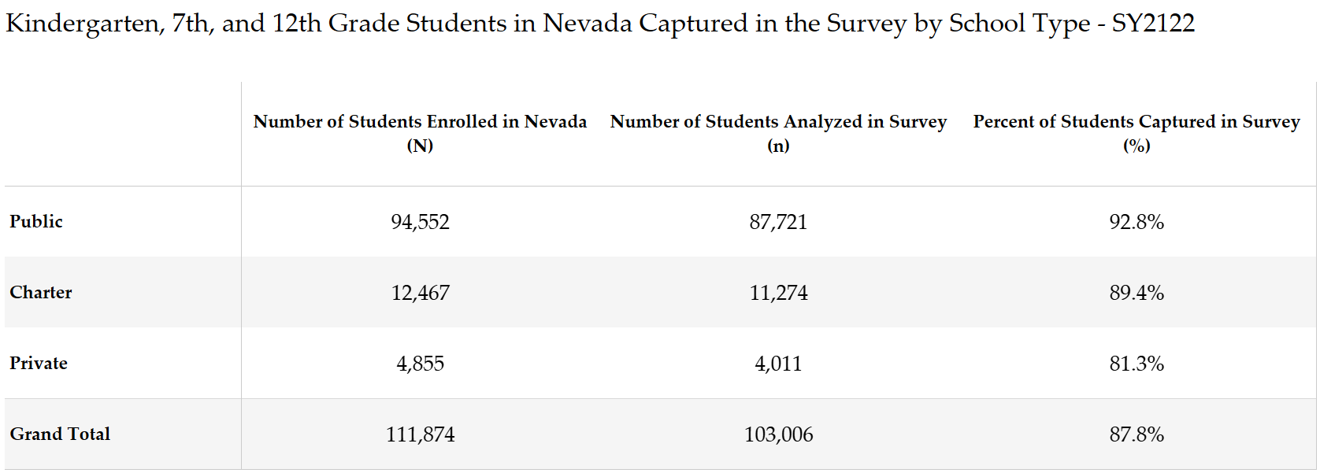
(Source: NDE and Annual Immunization Reporting Survey, 2021-2022)
Hispanic and white students in the grade levels of interest make up the largest share of students in both public and charter schools. Figures 1 and 2 display the race/ethnicity of students in grade levels of interest in public and charter schools as reported to NDE for the most recent school year, SY2122.
Figure 1: Breakdown of Race/Ethnicity Among Nevada Public School Students in Grade Levels of Interest – SY2122
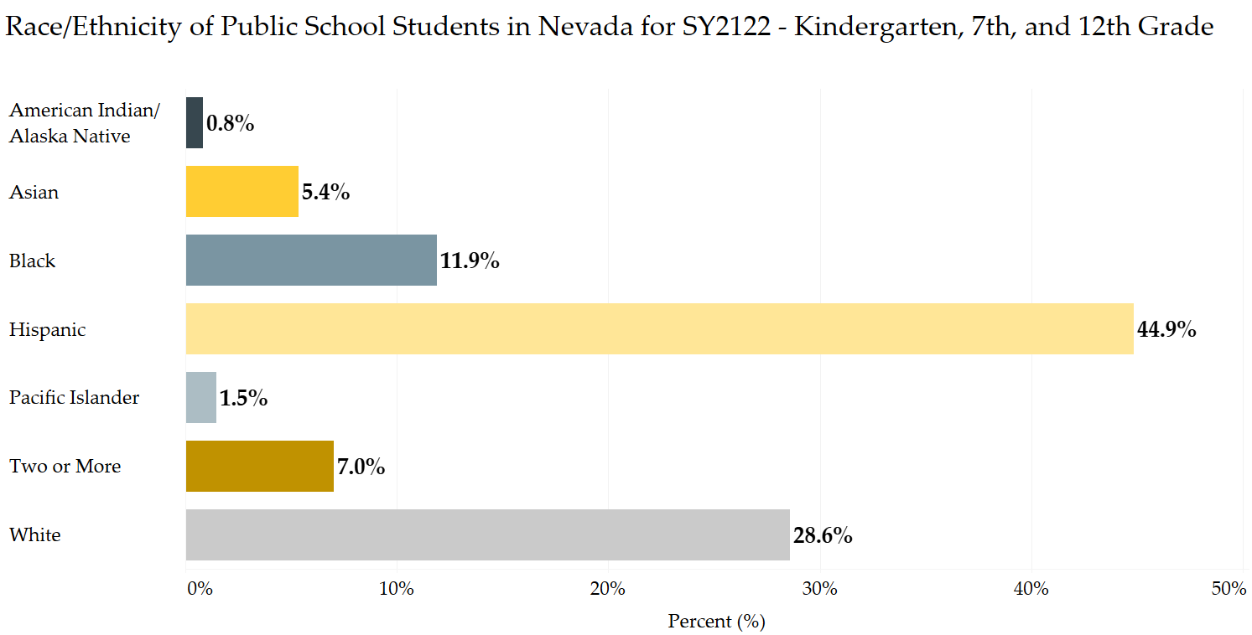
(Source: NDE Data Center, 2021-2022)

Figure 2: Breakdown of Race/Ethnicity Among Nevada Charter School Students in Grade Levels of Interest – SY2122
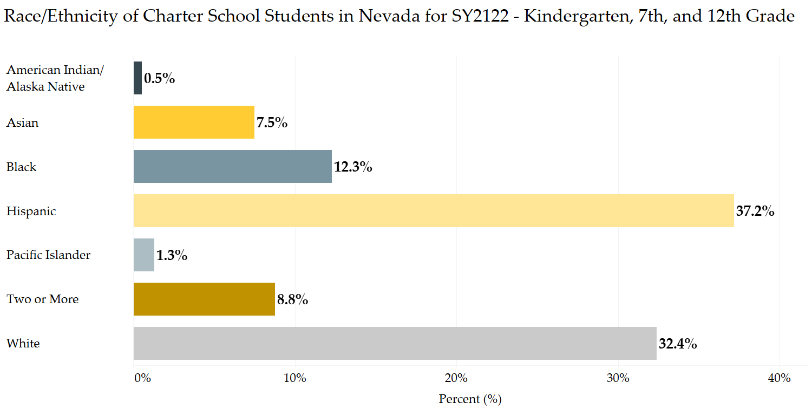
(Source: NDE Data Center, 2021-2022)
Per NAC 394, on or before October 15, private schools are required to submit two data points to
NDE to be posted publicly on the Department’s website: 1) total student enrollment by gender and grade level and 2) qualifications of each teacher employed by the school. Private schools are not required to provide student race/ethnicity data; therefore, none is reported for private school student populations in this report.
School-Required Vaccination Rates in Nevada – SY1920, SY2021, SY2122
Kindergarten
Children aged 4 to 6 are recommended by ACIP to continue their DTaP, IPV, varicella and MMR vaccination series that was started during infancy with an additional dose of each vaccine.³ In Nevada, children enrolling into early education programs, preschool, and kindergarten, must provide proof of vaccination against DTaP, IPV, MMR, hepatitis A and B, and varicella. Table 2 provides a breakdown of all school required vaccines for each school year. Vaccination rates for all vaccines increased between SY1920 and SY2021 before declining in SY2122.

Table 2: School Required Vaccines for Kindergartners in Nevada by School Year
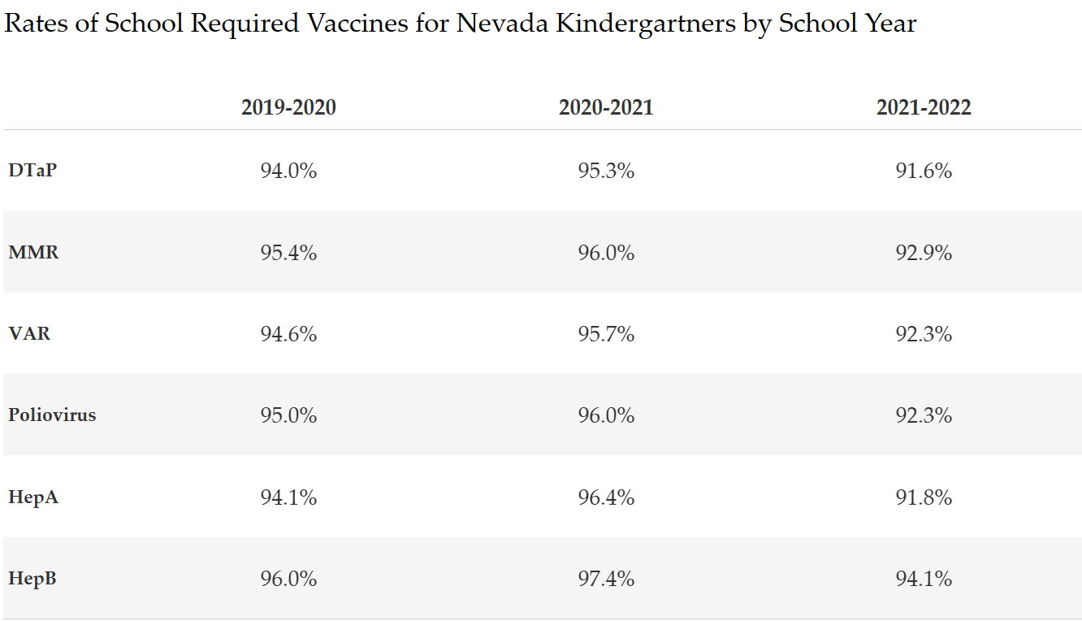
(Source: Annual Immunization Reporting Survey, SY1920-SY2021)
Since school vaccination requirements differ between states, the CDC selects certain vaccines to report in their MMWRs. To allow for comparison and context, Figure 3 displays rate of select school required vaccines that were similarly examined by the CDC in their April 2022 MMWR. In SY1920, Nevada kindergartners met the state’s compliance goal of 95% for MMR only (95.4%), while DTaP (94.0%) and Varicella (94.6%) fell slightly below. Rates increased for all vaccines for SY2021, meeting and exceeding the goal of 95% for that school year; however, a sharp decline was seen for all vaccines in SY2122.
Figure 3: Select School Required Vaccines for Kindergartners in Nevada by School Year – DTaP, MMR, Varicella
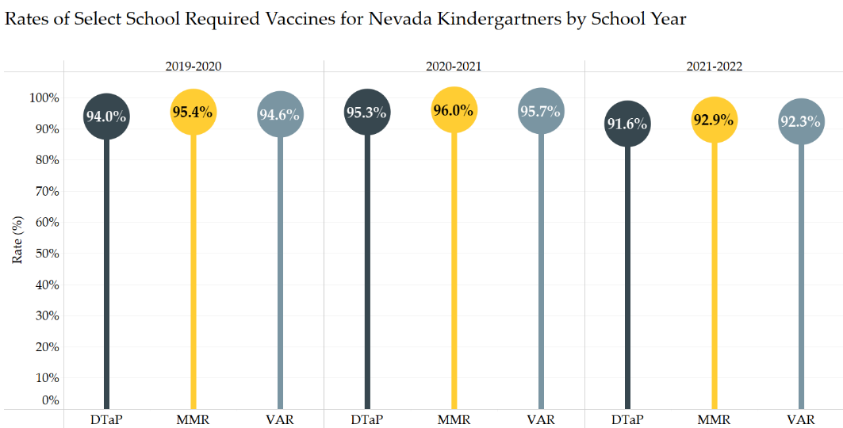
(Source: Annual Immunization Reporting Survey, SY1920-SY2021)
Figure 4 displays the rate of kindergarten students with religious and/or medical exemptions for each SY. The percentage of students with medical and religious exemptions remained at or below 4% for both SY1920 and SY2021; however, both types of exemptions increased in SY2122, with the rate of students with religious exemptions increasing by more than 17% for that school year.
Figure 4: Rate of Nevada Kindergarten Students with Exemptions
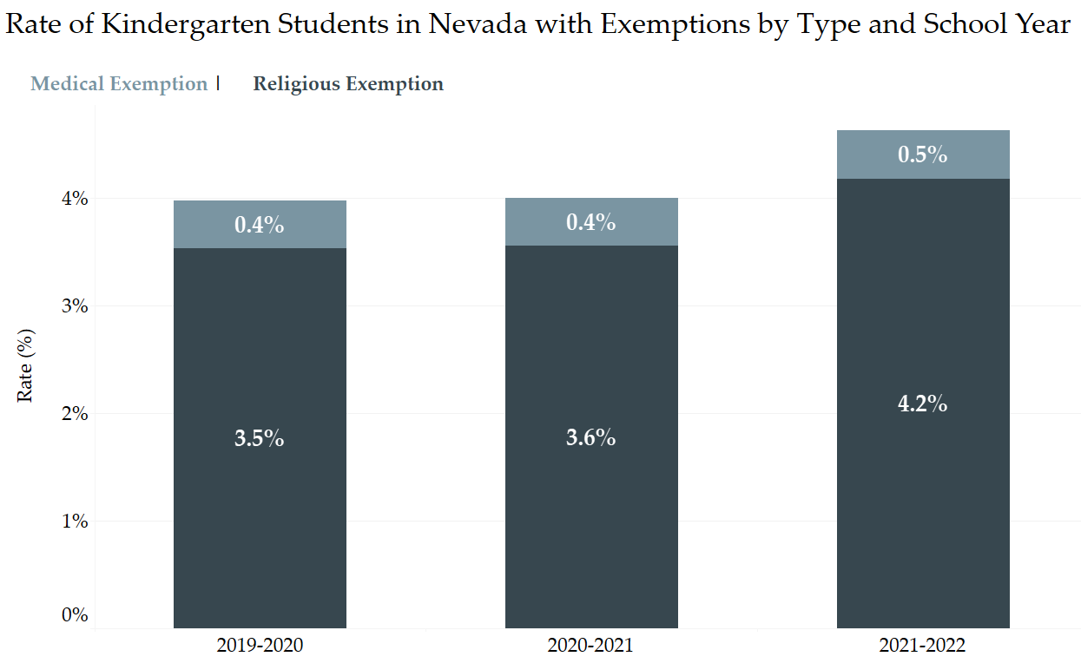
(Source: Annual Immunization Reporting Survey, SY1920-SY2021)
A district-level breakdown of kindergarten students with exemptions by type is below in Table 3 (also Appendix A). Religious exemption rates account for the bulk of student exemptions in Nevada and are higher than medical exemption rates in every district in the state.

Table 3: Rate of Nevada Kindergarten Students with Exemptions by District and Year
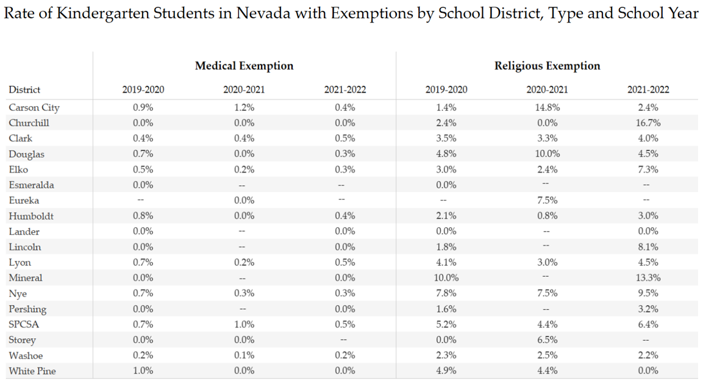
-- Data for the school year not available or not submitted.
(Source: Annual Immunization Reporting Survey, SY1920-SY2021)
Figure 5 depicts the rate of exemptions in public, charter, and private schools by exemption type and year. The percentage of students exempt from school-required vaccines is greater among private school students compared to public school students, a trend seen nationally and supported across research literature.⁴ In Nevada, private school students had higher exemption rates than their public and charter school counterparts for all three consecutive school years. Overall exemption rates increased among public, charter, and private school students for SY2122.
Figure 5: Nevada Kindergarten Student Exemption Rates by School Type (Public, Charter, and Private)
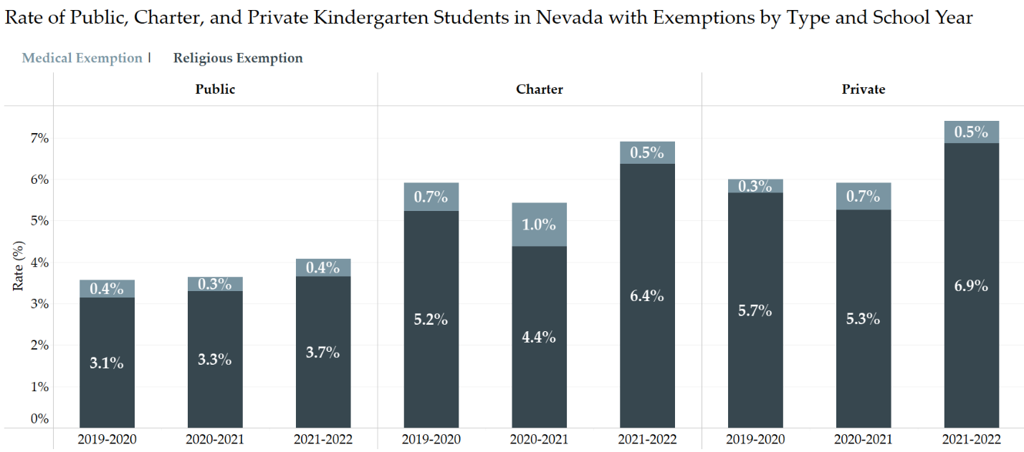
(Source: Annual Immunization Reporting Survey, SY1920-SY2021)
Key Takeaways
The decline in school-required vaccine rates observed in SY2122 could be connected to the increase in students exempt for that same school year. Students with religious exemptions from school-required vaccinations increased for public, charter, and private school students in SY2122.
7th Grade
Adolescents aged 11 to 12 are recommended by ACIP to receive one (1) dose of Tdap, MenACWY, and HPV vaccine (though adolescents can start their HPV vaccine series at age 9 years). In Nevada, adolescents enrolling in 7th grade are required to provide proof of vaccination against Tdap and receipt of one (1) dose of MenACWY.
Figure 6 displays the select school required vaccines that coincide with ACIP recommendations for this age group. Rates of MenACWY and Tdap vaccine were above the 95% compliance goal for SY1920. The COVID-19 pandemic likely impacted vaccine rates in SY2021 as both MenACWY and Tdap rates dropped below 90% for students. While rates increased in SY2122, they remain below their pre-pandemic threshold and the 95% compliance goal.
Figure 6: Select School Required Vaccines for 7th Graders in Nevada by School Year – MenACWY and Tdap
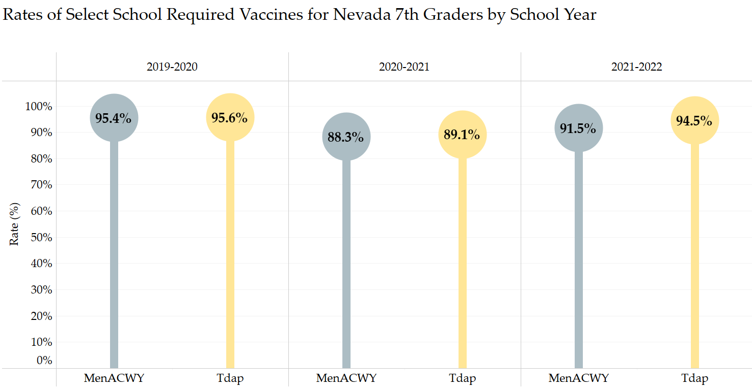
(Source: Annual Immunization Reporting Survey, SY1920-SY2021)
Figure 7 displays the rate of 7th grade students with religious and/or medical exemptions for each SY. For SY2021, both medical and religious exemption rates declined from the prior SY (-15.6% and -6.7%, respectively); however, in SY2122, medical exemptions rates increased by more than 63% while religious exemption rates increased by 10.4% from the prior SY.
Figure 7: Rate of Nevada 7th Grade Students with Exemptions
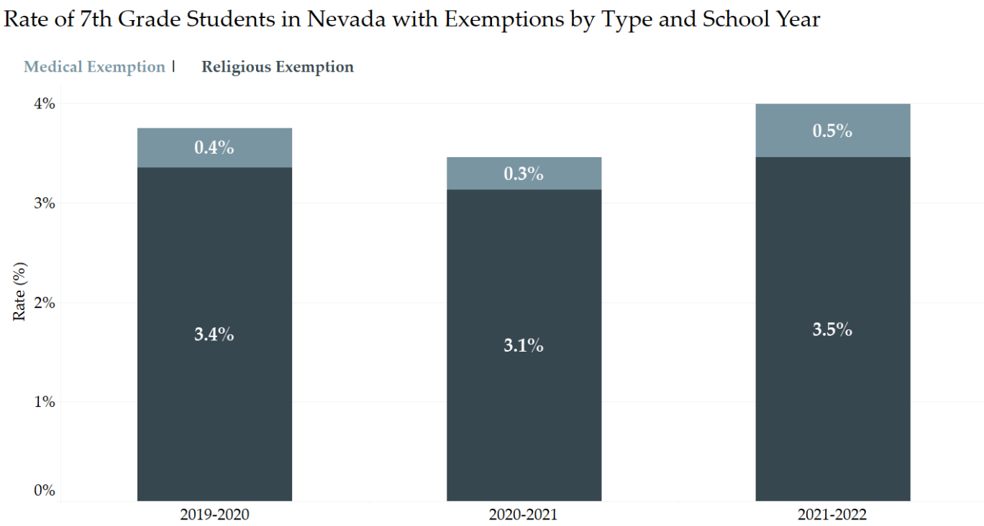
(Source: Annual Immunization Reporting Survey, SY1920-SY2021)
Figure 8 shows the rate of students with exemptions in public, charter, and private schools by exemption type and year. As was seen in kindergarten students, the rate of students with exemptions is higher among private school students compared to public school students; however, unlike kindergartners, charter school students in 7th grade have higher overall exemption rates than their public and private school counterparts, a trend seen across all three school years. Compared to religious exemption rates among 7th grade charter school students, which remained relatively stable between SY2021 and SY2122, medical exemption rates among 7th grade charter school students increased by more than 300% during that same period.
Figure 8: Nevada 7th Grade Student Exemption Rates by School Type (Public, Charter, & Private)
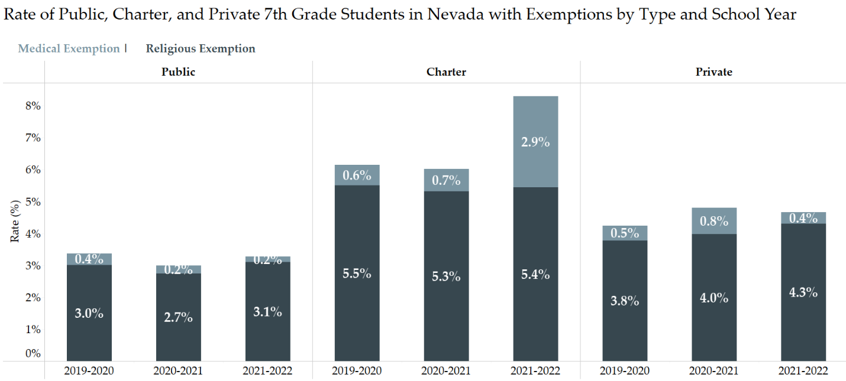
(Source: Annual Immunization Reporting Survey, SY1920-SY2021)
Key Takeaways
SY2021 saw a decline in MenACWY and Tdap rates for 7th grade students in Nevada, while overall exemption rates declined for that same SY. Since vaccination rates increased in SY2122, despite the increase in student exemption rates, the decline in vaccination rates seen in SY2021 was likely due to the delay in adolescent students receiving timely medical care, an impact of the COVID-19 pandemic.
12th Grade
ACIP recommends that adolescents receive their second dose of MenACWY at age 16 years. Routine vaccination against MenACWY is a 2-dose series, with dose 1 given between 11-12 years, and dose 2 delivered at 16 years. In Nevada, a student enrolling in 12th grade in a public, private, or charter school after June 30, 2022, must receive an immunization against meningitis in the form of a quadrivalent meningococcal conjugate vaccine (MenACWY). Students must receive at least one dose of MenACWY on or after 16 years of age. MenACWY vaccine administered on or after 16 years of age is considered part of the catch-up schedule and only requires one (1) dose. Resources for the 12th grade MenACWY requirement may be found here.
Figure 9 displays the rate of MenACWY vaccination among 12th grade students in Nevada. SY2021 saw a decline in MenACWY rates from the prior school year (-15.1%) but rates increased by more than 17% in SY2122, almost reaching the same rate observed prior to the COVID-19 pandemic in SY1920.
Figure 9: Select Vaccines by School Year – MenACWY
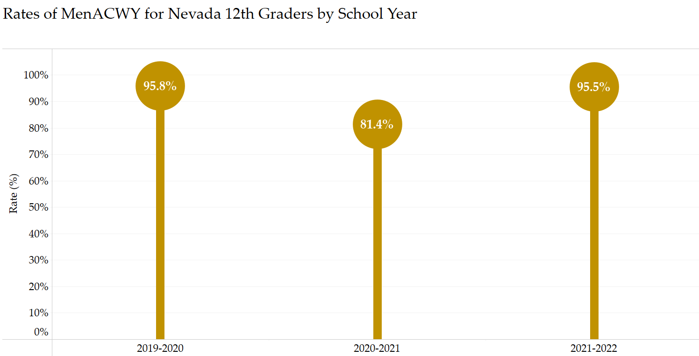
(Source: Annual Immunization Reporting Survey, SY1920-SY2021)
Figure 10 shows the percentage of students with exemptions by type and school year. Both medical and religious exemption rates declined for each subsequent SY between SY1920 and SY2122. Medical exemption rates declined by 30.1% in SY2021 and 8.4% in SY2122; religious exemption rates declined by 0.9% and 10.6% for the same school years, respectively.
Figure 10: Rate of Nevada 12th Grade Students with Exemptions
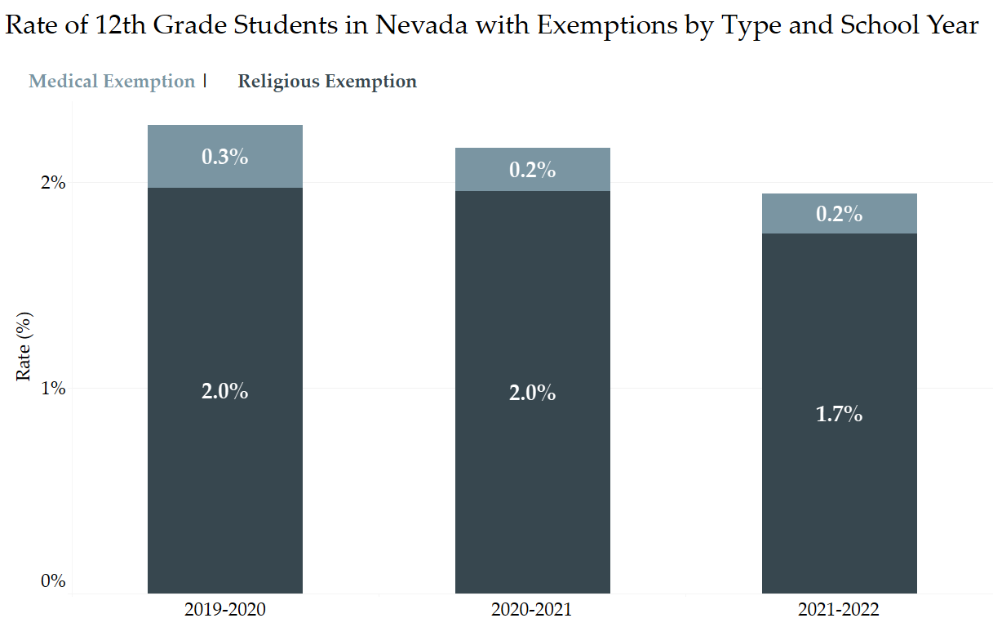
(Source: Annual Immunization Reporting Survey, SY1920-SY2021)
Figure 11 shows the breakdown of 12th grade students with exemptions in public, charter, and private schools by exemption type and year. The rate of students with exemptions is higher among private school students compared to public school students; however, like the trend seen in 7th graders, charter school students in grade 12 have higher overall exemption rates than their public and private school counterparts across all three school years. While public schools saw both religious and medical exemption rates decrease for SY2021 and SY2122, and charter schools saw overall exemption rates decline for SY2021 and SY2122, religious exemption rates among private school students increased by 17.0% (SY2021) and 45.7% (SY2122).

Figure 11: Nevada 12th Grade Student Exemption Rates by School Type (Public, Charter, and Private)
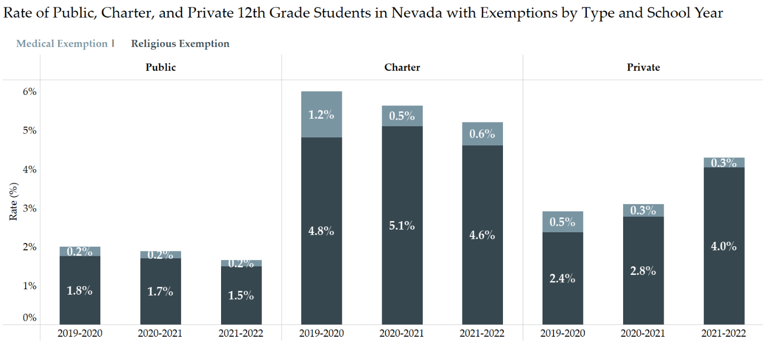
(Source: Annual Immunization Reporting Survey, SY1920-SY2122)
Key Takeaways
The COVID-19 pandemic had a clear impact on the MenACWY vaccination rates of 12th grade students during SY2021. Fortunately, MenACWY rates have rebounded in the most recent SY, while the new 12th grade requirement will likely improve MenACWY UTD rates throughout the state. Limitations to how MenACWY coverage is captured in the annual immunization reporting survey and the publication of this report prior to the release of the SY2223 annual immunization reporting survey prevent analysis on the impact of the new requirement at this time. Future iterations of the survey can hopefully capture MenACWY UTD rates more accurately and allow for analysis among 12th graders.
Comparison to the U.S. and Neighboring States
Departments of health and education work together to collect data from public school, private school, and homeschooled kindergartners in all 50 states, the District of Columbia, cities, and US territories.⁵ Immunization programs then submit vaccination coverage and exemption data to the CDC, and the CDC reports these data annually via multiple sources.⁵ An interactive dashboard on school vaccination and exemption data can be found at SchoolVaxView.
The CDC only publicly reports vaccination and exemption rates for kindergartners, and with each state having different school-entry requirements, comparing vaccination rates is challenging. Instead, a comparison can be made on allowable exemptions and immunization rates for select vaccines.
Figure 12 provides a national comparison of vaccination exemption rates for all 50 states and the District of Columbia for SY2021. Most states report exemption rates that fall within the 0.0%–5.0% range; Oregon, Utah, Arizona, and Wyoming exemption rates are between 5.0%–7.5%, while Idaho stands alone with the highest exemption rate between 7.5%–10.0%.

Figure 12: Map of Exemption Rates Among Kindergartners Across the United States for SY2021
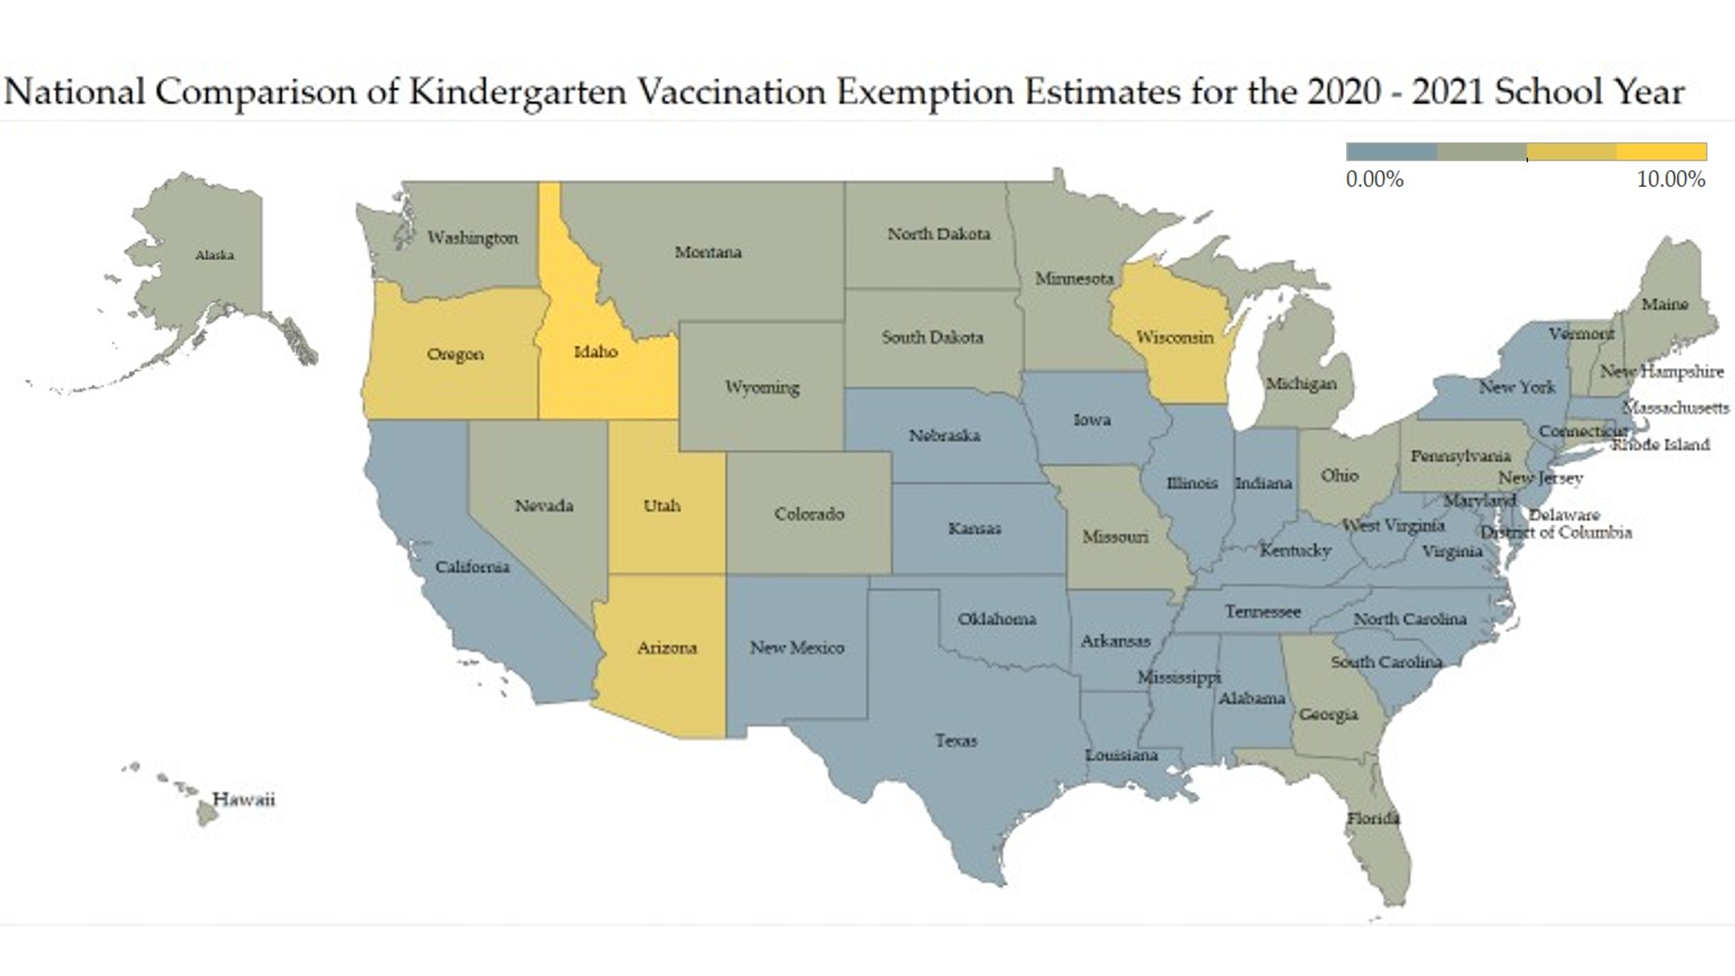
(Source: NCIRD, SY2021)
Figures 13 and 14 display vaccination coverage and exemption rates in Nevada compared to the US and neighboring states of California and Utah. California only allows medical exemptions from immunization which can explain its lower overall exemption rate compared to Nevada, the US, and Utah. Utah allows for medical, religious, and philosophical exemptions. The allowance of philosophical or personal belief exemptions in Utah likely accounts for the higher overall exemption rate seen in the state. Despite the lower exemption rates reported among students in California and estimated among students in the US, Nevada kindergarteners have higher rates of vaccination coverage for all three select vaccines.

Figure 13: Comparison of Exemption Rates for 2019–2020 and 2020–2021 School Year
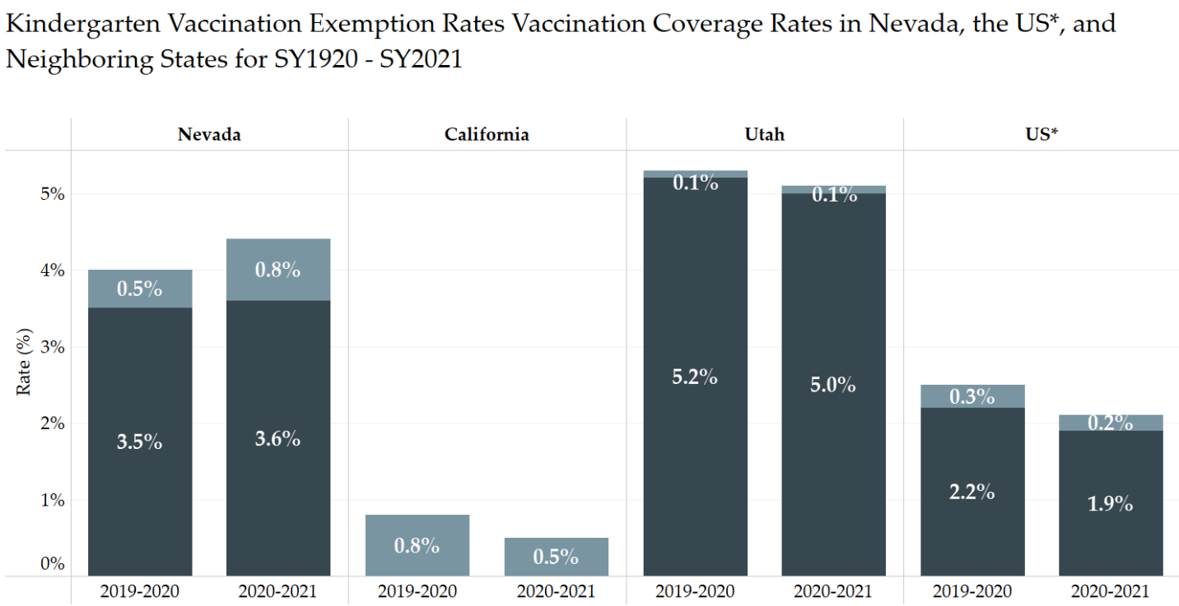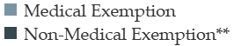
*National estimates are the sum of the weighted number of kindergarteners with the number of exemptions divided by the sum of the state kindergarten populations.
**Denotes any exemption type that is not a medical exemption, including religious and philosophical exemptions.
(Source: NCIRD, SY1920-SY2021)
Figure 14: Comparison of Vaccination Coverage Rates for Select Vaccines for the 2020–2021 School Year
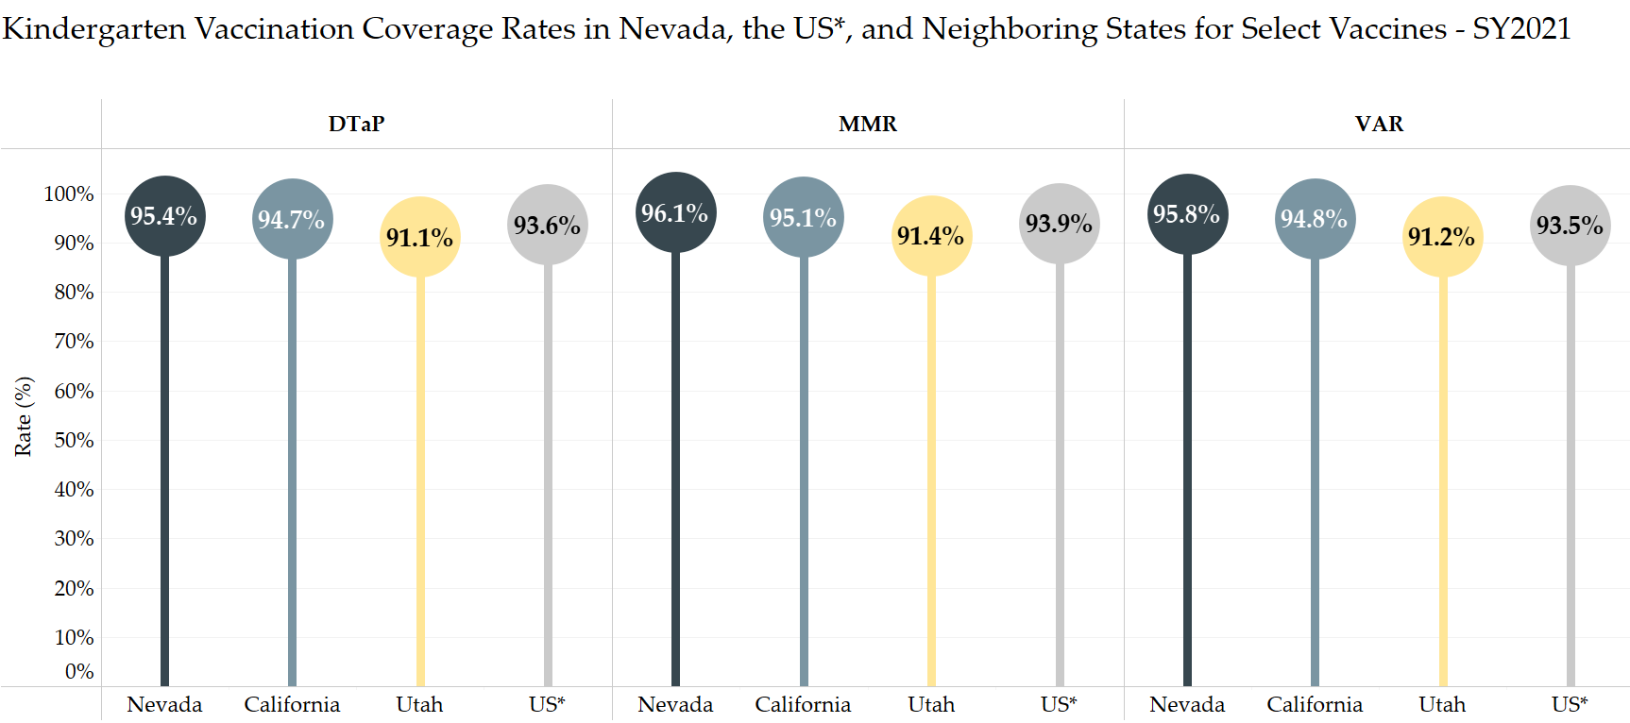
*National estimates are the sum of the weighted number of kindergarteners with the number of vaccination doses divided by the sum of the state kindergarten populations.
(Source: NCIRD, SY1920-SY2021)
Discussion: Vaccination Policy and the Impact of COVID
School vaccination requirements have been a part of school-entry policies for decades and they have largely contributed to safeguarding the public health of students, teachers, families, and communities. The COVID-19 pandemic resulted in states taking action to ensure their student and teacher populations remained safe from COVID-19 transmission through mask mandates, and eventually vaccine mandates: California and the District of Columbia both require COVID-19 vaccination for school-entry in 2022, while some cities, counties, and school districts have included COVID-19 vaccination requirements for certain activities, such as sports participation, or for certain age groups.⁶ Conversely, some state legislatures took up opposing actions to prevent COVID-19 mitigation efforts in schools, either to mask mandates or vaccine requirements, which shone a spotlight on school vaccine requirements more broadly. ^{6,7}
Concern that pushback to COVID-19 mitigation efforts would impact other ACIP recommended and routine childhood vaccine requirements reinforces the need to continue educating on the safety and efficacy of vaccines. Schools are environments where people gather in close proximity, making their risk for potential outbreak high. As outbreaks occur in unvaccinated communities across the country—polio in New York and meningococcal in Florida—it is imperative that vaccination efforts continue to safeguard and protect Nevadans against preventable diseases.
Vaccines are safe, effective, and protect against vaccine preventable diseases. Continued education and outreach on the safety and efficacy of vaccines is crucial to ensure that as many Nevada children get vaccinated.

References
- Hill, H.A., Yankey, D, Elam-Evans, L.D., Singleton, J.A., Sterrett, N. (2021). Vaccination coverage by age 24 months among children born in 2017 and 2018 — National Immunization Survey-Child, United States, 2018–2020. MMWR Morbidity and Mortality Weekly Report, 70(41), 1435–1440. http://dx.doi.org/10.15585/mmwr.mm7041a1
- Pingali, C., Yankey, D., Elam-Evans, L.D., Markowitz, L.E., Williams, C.L., Freuda, B., McNamara, L.A., Stokley, S., Singleton, J.A. (2021). National, regional, state, and selected local area vaccination coverage among adolescents aged 13–17 years — United States, 2020. MMWR Morbidity and Mortality Weekly Report, 70(35), 1183–1190. http://dx.doi.org/10.15585/mmwr.mm7035a1
- Centers for Disease Control and Prevention (CDC). (n.d.). Child and adolescent immunization schedule: Recommendations for ages 18 years or younger, United States, 2022. Retrieved September 7, 2022, from https://www.cdc.gov/vaccines/schedules/hcp/imz/child-adolescent.html
- Shaw, J., Tserenpuntsag, B., McNutt, L. A., & Halsey, N. (2014). United States private schools have higher rates of exemptions to school immunization requirements than public schools. The Journal of Pediatrics, 165(1), 129–133. https://doi.org/10.1016/j.jpeds.2014.03.039
- Mellerson, J.L., Street, E., Knighton, C., Calhoun, K., Seither, R., Underwood, J.M. (2020). Centers for Disease Control and Prevention's school vaccination assessment: Collaboration with US state, local, and territorial immunization programs, 2012-2018. American Journal of Public Health, 110(7), 1092-1097. https://doi.org/10.2105/AJPH.2020.305643
- National Conference of State Legislatures (NCSL). (2022, May 25). States with religious and philosophical exemptions from school immunization requirements. Retrieved September 8, 2022, from https://www.ncsl.org/research/health/school-immunization-exemption-state-laws.aspx
- Gould, Z. (2021, November 9). States take action on vaccine mandates in schools. National Academy for State Health Policy (NASHP). Retrieved September 8, 2022, from https://www.nashp.org/states-take-action-on-vaccine-mandates-in-schools/

Appendix A

Table 3 (enlarged)

